# JWT Token

1. Stateful session
2. Stateless session

### Problem with Stateful HTTP sessions

Stateful sessions means server will remember the state because once authentication is success then sessions/session object is created and session object will be stored in the server

And user should pass the session id in each request

Session object is nothing but object of class implementing HTTPSession it’s a MAP

when user logs out we should invalidate the session and that object gets removed from the server ,

if 1Million people logged in then 1Million session objects will be created and stored on the server

Issue : hacker can come and tap the session id

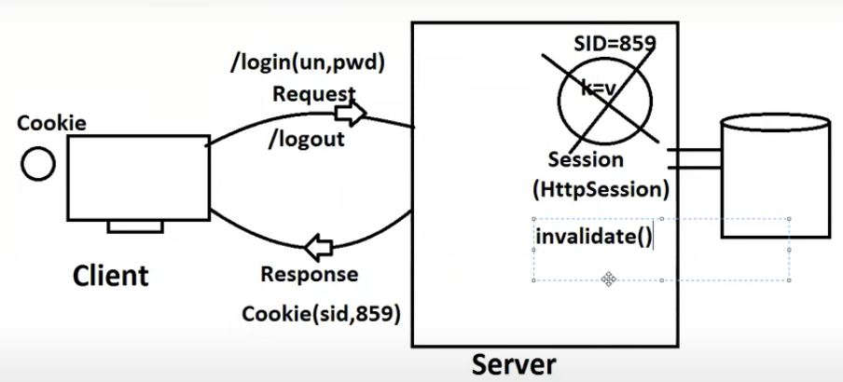

### Stateless sessions

Means client data wil not be stored in the server and server will not maintain the user details and unlike above there won’t be any session object created as server wont store any thing

Here every request is a new request

Then how authentication takes place??

Simple for every request we should pass some temporary token String in the header, this token is valid upto some 10-20 minutes

Use case:-

1. in web services mostly we will use stateless authentication as server wont remember anything and doesn’t track anything
2. especially in microservices horizontal scaling apps we should use this token means stateless sessions

Stateless sessions are good for micro services

In horizontal scaling Stateless sessions are best fit

Stateless means server won’t maintain any state of user like server will not maintain any session objects every request is fresh request, for every request u should pass token

If you consider an app which is scaled 3 times in prod, if u maintain Stateful session, then problem is

1) 1st request may go to server1 and second time due to load on same server-1 , same user might be redirected to server -2 on next request, Session objects needs to be created in 3 servers and when user logs out we have to invalidate the session in 3 instances which is an overhead, but still if u want to avoid that we have some sticky sessions like if user request if it went to server-1 we can always ensure all his requests should go to server-1 but why to take risk so in micro services better go with stateless

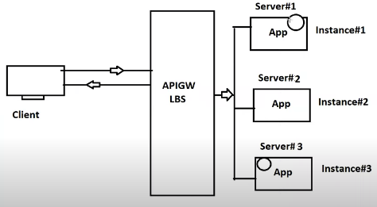

Limitations of stateless sessions

Token must be validated on each and every request we should check whether token is valid or not and keep that logic in Rest template interceptor

Benefits

Server doesn’t need to maintain the user session objects and no need to invalidate the session in all replicas when user invalidates the session

## JWT

JWT json web token is an open source API used to generate the token based on client details and secret key

Reference jwt.io

Dependency information is

implementation **'io.jsonwebtoken**:jjwt-api:0.11.2'

if u are using >java 8 add jaxb dependency manually because it was removed from java 11 onwards I think

// https://mvnrepository.com/artifact/javax.xml.bind/jaxb-api

implementation 'javax.xml.bind:jaxb-api:2.3.0'

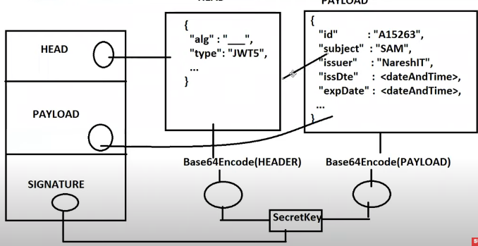

Code to generate Token

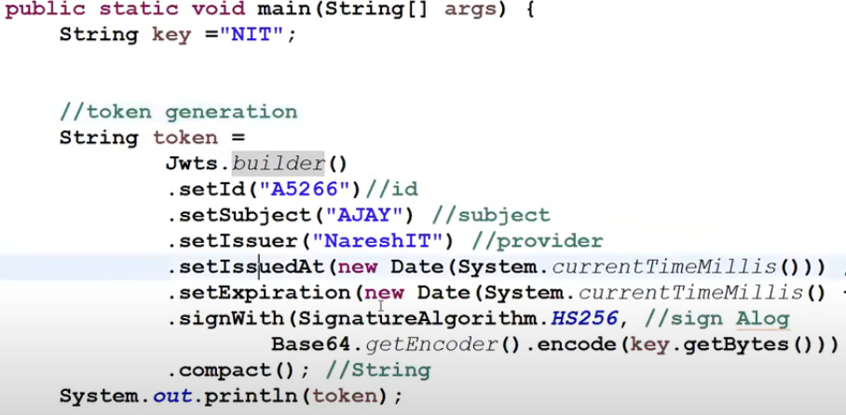

There are many signature algorithms to generate the token like HS256 or HM245…

Base64 is the class given by java 8

We should set token expiration time , subject is the main thing

And output will be like

XXXXXXXX.YYYYYYYYYYYYYYYYYYYYYYYYY.ZZZZZZZZZZZZZZ

Header.payload.signature

Extracting token

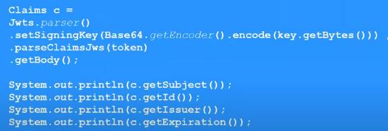

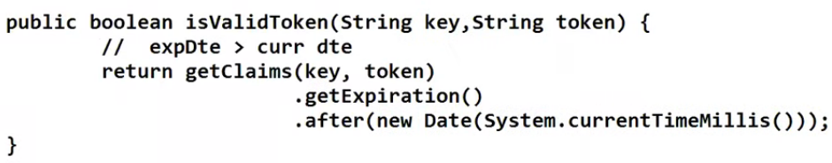

Practice:

1. modify the token and see
2. use an expired token and see what happens